What
is
the
Coronavirus?

The coronavirus is a virus that can make people feel sick.

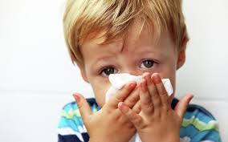

People who have the virus can have a:

Sore throat
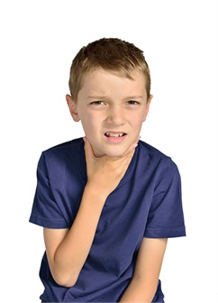

Dry Cough
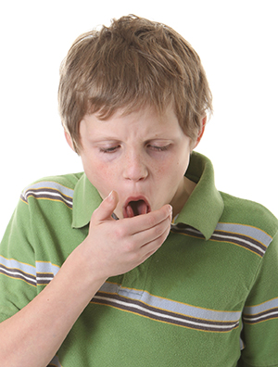
Fever
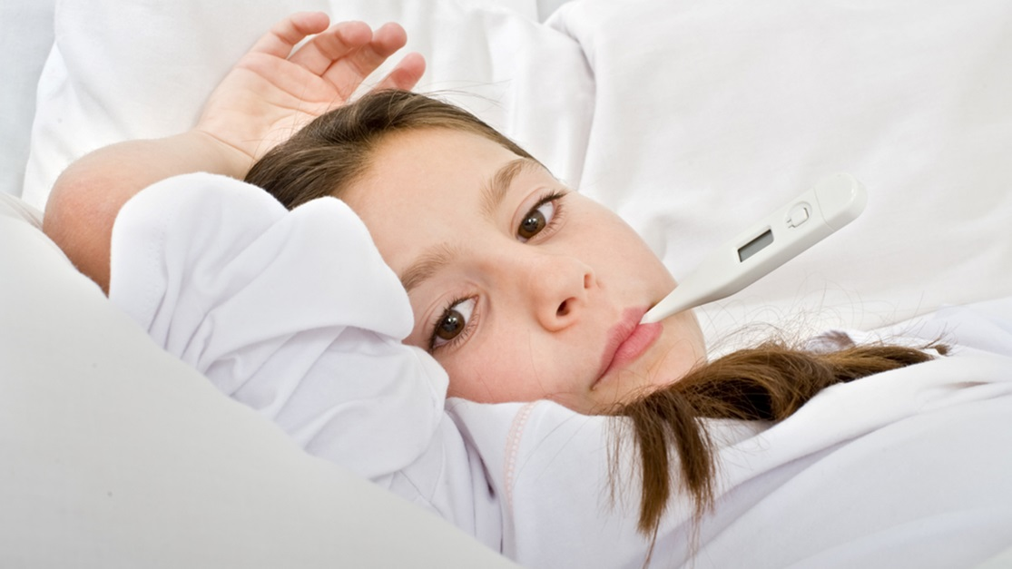
Shortness of breath
that makes it hard to breath



I may have to see the nurse or doctor


If I get sick I will have to stay home and rest

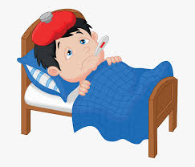

I won’t be able to be around others or have my family visit until I get better.

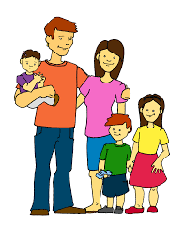
One thing I can do to be healthy is
wash my hands with soap.

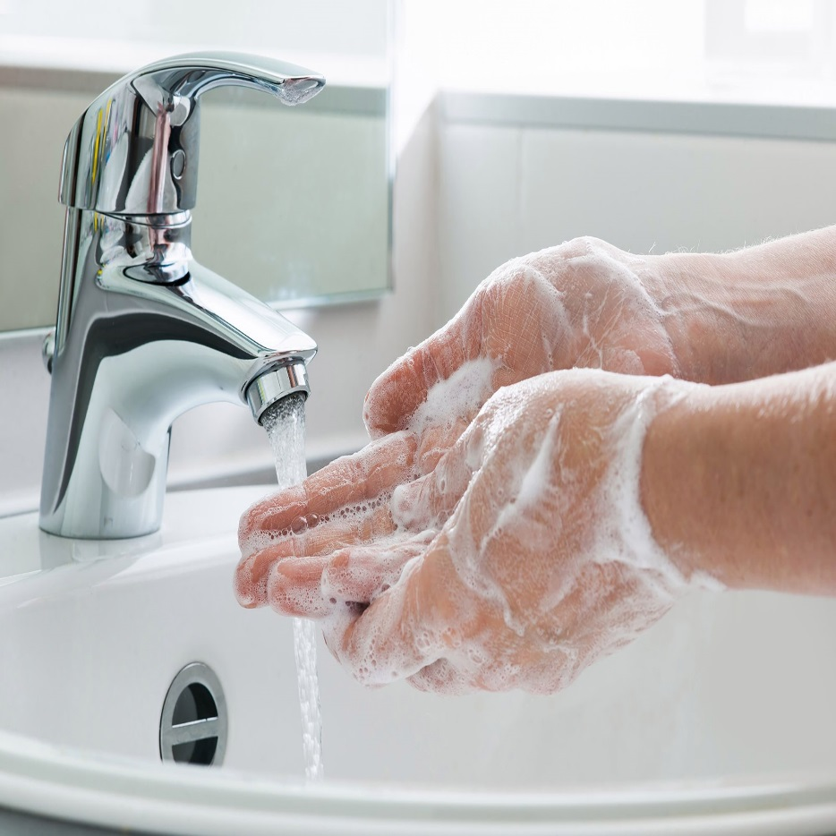
I should sing Happy Birthday two times so I know my hands are clean!

I should use a paper towel to dry my hands!
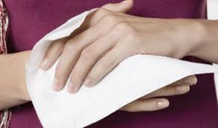
I can also use hand sanitizer if I see a bottle of it.

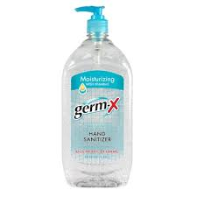
I should use a tissue if I sneeze or cough to cover my nose and mouth.

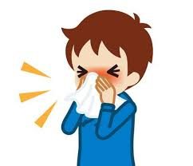
If I don’t have a tissue I should sneeze or cough into my elbow.

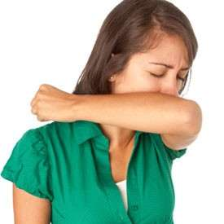

Remember to wash your hands and use a tissue to stay healthy!



